Chapter 8, Problem 18.

Find the voltage across the capacitor as a function of time for t > 0 for the circuit in Fig. 8.72. Assume steady-state conditions exist at t = 0⁻.

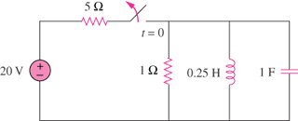
100 V

Figure 8.72
For Prob. 8.18.

